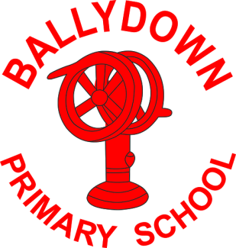
Ballydown Primary School & Nursery Unit
64 Lisnaree Road
Banbridge
Co Down
BT32 4JS
Tel:- 028 40662738

Principal: Mr B Murphy M.Ed. B.Ed. PQH(NI)

Janaury/February Information

Parent/ Teacher Interviews
Due to the pandemic we will hold Nursery-P6 parent/teacher interviews a little later this term, 14th-16th March 2022. We hope that by then we will be able to have face-to-face interviews rather than telephone/online interviews. We feel it is so important to have a face-to-face meeting with you to discuss your child’s progress and answer any questions/concerns you may have. We have really missed the opportunity to meet with parents properly over the past two years. If you wish to discuss any concerns, you may have, then please do not hesitate in contacting us prior to then.

P7 interviews will take place 7th-9th February, following the publication of AQE results 5th February. This will give you the opportunity to discuss post-primary transfer and give advice regarding your choice of placement. Please refer to EA website for details on how to make your application for Post Primary and for the admissions criteria for each school.

https://www.eani.org.uk/parents/admissions (post primary applications open 1st-23rd February)

Details on making interview appointments to follow.

Covid Update
Thankfully covid case numbers appear to be under control, for the moment. We still have some children/parents testing positive, but thankfully symptoms appear to be much milder. Please continue to be cautious for signs and symptoms. If in doubt keep your child off and use a lateral flow to test them. We continue to see the pattern that siblings of positive cases are highly likely to become infected; often several days later. Our advice is to keep siblings off for at least 2 days and use lateral flow tests before returning to school. We will continue to do our best to keep cases numbers under control to allow school to continue functioning as normally as possible.

Nursery and P1 applications
Nursery and P1 applications are currently open until 12 noon 28th February. Nursey is already looking like it will be oversubscribed with siblings. P1 places are still available. Parents of current nursery children should remember to make their application. If you know of any new P1 families wishing to visit us, please ask them to contact the office.

Southern Area Hospice Christmas Performance Fundraiser
A huge thank you on behalf of the Southern Area Hospice. They were so delighted to receive a cheque for £1500 from Ballydown Primary School. We cannot thank you enough for your kindness and generosity.

Arrival and Exiting
Early Birds Club opens 8.00am.

School doors open from 8:45-9:05am. Please try to be punctual.

Home time is always busy in the car park. We know space is very limited but please continue to be sensible with your parking, to allow traffic to keep moving and to ensure the safety of pupils as they exit. It is very important to keep the bus stop clear and to allow the bus in and out.

P3
P3 children will begin to stay for their late days on Wednesdays and Thursdays from after half term, beginning Wednesday 23rd February.

Half Term
Half term holiday 14th-18th February 2022.

Yours sincerely,

B. Murphy
Principal

Phone: 028 4066 2738
E-mail: bmurphy490@c2kni.net website: ballydownprimary.org.uk

