**Governors’**

**Report**

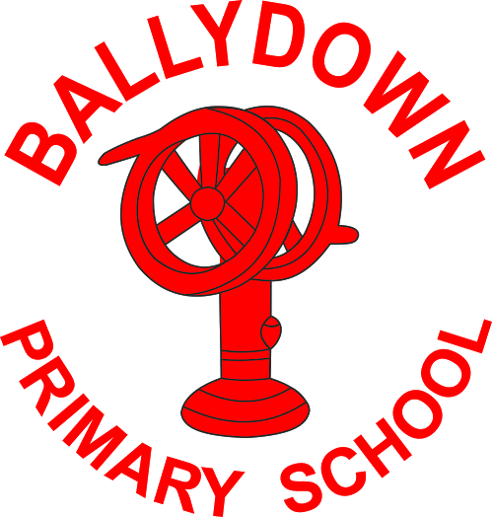

**Ballydown**

**Primary School &**

**Nursery Unit**

**2018-2019**

***‘A quality education in a caring environment’***

***Ballydown Primary School***

***Annual Governors Report 2018/19***

*1*

*Dear Parent,*

*This is our annual Board of Governors Report for last year 2018/19. It reflects on the work carried out in the school over the past year and provides an overview of the many activities which take place in our school and which help to make Ballydown the vibrant learning environment that it is. We hope you find it informative.*

*If you have any queries please get in touch with the principal, Mr Murphy.*

*Yours faithfully*

*B Martin*

***Rev B Martin***

***Chairman of Board of Governors***

**Ballydown Primary School**

**Board of Governors 2018-19**

**Composition of the Board**

Rev Brian Martin Chairperson

Rev Liam Rutherford Vice Chairperson

Mr Brian Murphy Hon. Secretary

**Transferor Representatives**

Mrs Alison McQuiston

Mr Andrew Beattie

**EA Representatives**

Mrs Mary Mark

Mr Stephen Cassells

**Parent Representatives**

Mrs Mandy Gibson

Mr David Porter

**Teacher Representative**

Mr Trevor Russell

**Principal**

Mr Brian Murphy

The Governors are ultimately responsible for the overall management of the school.

Our duties include:

1. The oversight of the curriculum
2. The control of the budget
3. The provision of information to parents
4. The selection of staff
5. The maintenance of the premises (shared responsibility with the EA)
6. The Admission Policy
7. Fostering links with the local community

The Board of Governors is required to meet a minimum of three times in the year and were involved in implementing most of the above duties. The Board of Governors is pleased to note that the school continues to grow, maintain high educational standards and plays a significant role in the life of the community.

We recognise the commitment, dedication and hard work of all the teaching and non-teaching staff and would like to thank them for their efforts on our children’s behalf.

The Board of Governors also put on record their appreciation of the Parent Teacher Association which does so much to raise the profile of the school in the community, draw parents into the ongoing life of the school and raise money for much needed materials and equipment.

We would like to extend our appreciation to those members who have completed their term and wish them well for the future.

**Rev B Martin,**

**Chairman of Board of Governors**

**TEACHING STAFFING – 2018/19**

Mr B Murphy/Mr W McMullan (term 1) Principal

Mr T Russell Vice-Principal P7

Mrs J Wright Head of Foundation/Key Stage I Mrs L Baird SENCO

Mrs D Russell/Mrs M Thompson (Flexible working) P1

Mrs J Wright P1

Miss J White P2

Mrs S Lindsay P2/P3

Mrs A Irvine P3

Mrs B Glass / Mrs R Stewart (Flexible working) P4

Mrs J Duke P4/P5

Miss J Orr P5

Mrs P Coulter/ Mrs M Thompson P6

Mrs K Blair P6/P7

Mrs N Hamilton Nursery

***Senior Management Team***

Mr B Murphy,

Mr T Russell, Mrs K Blair,

Mrs J Wright

BD06622_

# **Staff - 2018/19**

Mrs M Graham Clerical Assistants

Ms S Oakes (from Feb 2019)

Mrs J Matchett/ Mrs J Eadie (Nursery Classroom Assistant)

Mrs P McCall/Mrs J Eadie (P1 Classroom Assistant - DENI Initiative)

Mrs M James (P2 Classroom Assistant - DENI Initiative)

Mrs J Copes (Special Needs)

Mrs W Elliott (Special Needs)

Mrs S Hinds (Special Needs)

Mrs C Morrison (Special Needs)

Ms T Gordon (Special Needs)

Mr S Cairns (Special Needs)

Mrs H Gillham (Special Needs)

Mr J Bingham (Building Supervisor)

Mr B Williamson/ Mrs T Horner (Cleaners)

Lunchtime Supervisory Assistants

Mrs E Farr

Mrs D Cowan

Mrs B Thom

**School Meals Staff - June 2019**

Mrs S Annett, Cook

Mrs E Smyth, Mrs J Russell, Mrs M Boone.

*Our special thanks go to them for their continued provision of an excellent variety of healthy school dinners.*

1. **Teaching and Learning - The** **Curriculum**

**Literacy**

* An analysis of our data indicates that, when Benchmarked against the National Mean score of 100 in Performance in English (PIE/PTE), the school achieved a mean score of **110 in 2018/19**
* Benchmarked against National Stanine Distributions, where Stanine 5 represents 60% of children in the national standardised scores, an analysis of school results show that in every year, the school was performing well above this % score of 60% and in 2018/19 we attained a **class average of 83%.**
* The number of children achieving well ABOVE EXPECTATION in Literacy/Communication has been INCREASING.
* An analysis of the school’s scores against the national percentage scores, reveal that in each category of Literacy in 2018/19 (in Curriculum Content and Reading Comprehension), the percentage of correct answers, in every area, and in every class, was above the national percentage.
* An analysis of the PIE/PTE scores indicates that all classes are performing above the National Percentage.

Throughout the key stages, the pupils were given many opportunities to express their opinions and share their ideas, doing so with clarity and confidence. By the end of the year, the pupils had had many opportunities to read texts from a wide variety of authors with high levels of understanding. They were able to competently discuss writers’ choice of language and recognise explicit and implicit meaning. Throughout the school, all pupils can write with increasing independence and accuracy across a wide variety of literary genres. They had many opportunities to plan, edit and review their writing. The pupils presented their writing in a variety of different formats, including digital texts, to suit the reader and audience.

Teachers planning for Literacy ensured progression across the key stages. The teachers made use of stimulating and challenging resources to provide the pupils with opportunities to engage in purposeful discussion and planning about their work which led to their production of high quality writing.

Annual World Book Day was celebrated again in March when all of the pupils and staff dressed up as a character from a book. There were many related activities carried out in each classroom and pupils engaged in paired reading, where each of our KS2 classes visited a KS1 class and read a favourite book (brought in from home) to the children. Pupils were also encouraged to bring in a photo of them reading in an unusual place!

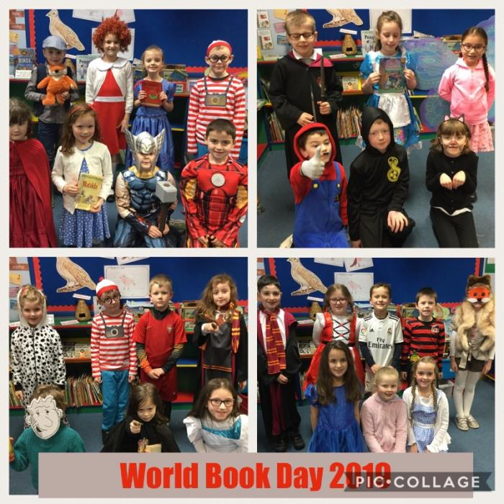

The P7s had a focused study on a selection of Ulster Scots language and literature, highland dance and music which culminated in a “Burns’ Assembly.” All of the P7 pupils took part in some way in this assembly.

[](http://www.google.co.uk/url?sa=i&rct=j&q=&esrc=s&source=images&cd=&cad=rja&uact=8&ved=2ahUKEwj9nMSK9-bkAhUgRxUIHaX8Ds0QjRx6BAgBEAQ&url=http://rediumtrade.com/motivational-quotes-for-a-school/&psig=AOvVaw3iuLKTp4_UJeOGaMWJ-2DC&ust=1569314219785196)

**Numeracy**

* Benchmarked against the National Mean score of 100 in Performance in Maths (PIM/PTM), the school achieved a mean score of **109.5 in 2018/19.**

.

* Benchmarked against National Stanine Distributions, where Stanine 5 represents 60% of children in the national standardised scores, an analysis of school results show that in every year the school was performing well above this % score of 60% and in 2018/19 we attained a **class average of 86%.**
* The number of children achieving ABOVE EXPECTATION in Mathematics/Numeracy has been INCREASING, while the number of children UNDERACHIEVING in Mathematics is 17 children in 2018/19).
* An analysis of the school’s scores against the national percentage scores, reveal that in each category of Mathematics in 2018/19 (ie Number, Shape and Space and Measures, Handling Data, Processes etc), the percentage of correct answers, in every area, and in every class, was above the national percentage.

**LITERACY : Progress Test in English – 2019**

|  |  |  |  |
| --- | --- | --- | --- |
| **Year Group** | **BOYS**  **Mean SS** | **GIRLS**  **Mean SS** | **All Pupils**  **Mean SS** |
| **P3 (PTE)** | 103.7 | 111.0 | 107.7 |
| **P4 (PTE)** | 109.3 | 113.1 | 111.3 |
| **P5 (PTE)** | 104.7 | 112.6 | 109.3 |
| **P6 (PTE)** | 107.2 | 118.1 | 112.7 |
| **P7 (PIE)** | 107.59 | 111.69 | 109.81 |

**National Mean SS = 100**

**NUMERACY : Progress Test in Maths - 2019**

|  |  |  |  |
| --- | --- | --- | --- |
| **Year Group** | **BOYS**  **Mean SS** | **GIRLS**  **Mean SS** | **All Pupils**  **Mean SS** |
| **P3 (PTM)** | 108.8 | 109.8 | 109.3 |
| **P4 (PTM)** | 108.3 | 108.1 | 108.2 |
| **P5 (PTM)** | 110.5 | 111.3 | 111.0 |
| **P6 (PTM)** | 110.0 | 108.7 | 109.4 |
| **P7 (PIM)** | 106.91 | 112.19 | 109.77 |

**National Mean SS = 100**

In conclusion,our data reveals that the school’s scores are commendably high, indicating high standards of teaching and learning in Mathematics and Numeracy.

**Maths Week**

The School ran “Maths Week” from 14th to 18th January 2019 when each class engaged in a variety of problem solving investigations, practical activities and numeracy trails. It is important for children to see that Maths is Fun and this week provided a great opportunity to demonstrate this.

***World Around Us***

The success of our two year rolling programme of study throughout the primary school continues to be the basis from which pupils enjoy their WAU experiences. This allows the split P2/3, P4/5 and P6/7 pupils from repeating WAU topics. Planners are updated to include new ideas and experiences to develop pupils learning experiences.

Teachers are using ICLs and thematic units to enhance pupils learning.

The learning opportunities afforded by the Rath continue to be explored and exploited in a variety of cross curricular ways. These greatly enrich the pupils learning experience as children actively develop new skills during lessons.

P5 made use of a fabulous Identification Key to investigate over 15 different types of spring flowers found growing wild around the Rath.

We have been delighted that the WAU has become an essential aspect of our Shared Education planning and projects. We welcomed pupils from St. Francis P.S. to explore our Rath. Whereas our pupils, had the opportunity of exploring and investigating Whyte’s Estate and other aspects of Loughbrickland village.

**School trips** such as London, Scotland and Cultra are embedded in our curriculum to ensure that the learning experience as a pupil at Ballydown can be as enriching as possible.

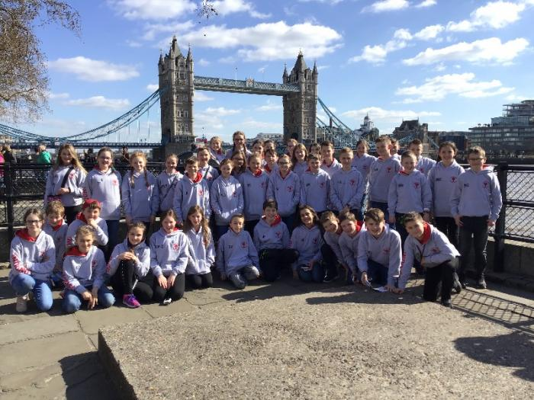

It is with delight that this year we were able, through Shared Education, to extend these learning experiences to include an ascent of Slieve Gullion by P7 pupils. There they were able to view the world famous collapsed caldera known as the Ring of Gullion.

An integral part of our WAU programme was our **Technology Day** in October 2018 when children planned, designed, constructed and reviewed their given construction task. The day ended with children demonstrating their models to other children in the hall.

***The******Arts***

***Music***

Music stimulates the mind, encourages creativity, self-discipline, patience, sensitivity, co-ordination and the ability to concentrate and memorize.

***Instrumental Tuition***

Each pupil at Ballydown had the opportunity to develop their musical skills through the delivery of the curriculum, a variety of extra-curricular activities and with the support from visiting peripatetic teachers.

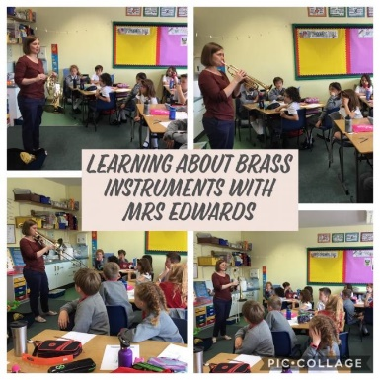

Children received woodwind and **brass tuition** provided by two peripatetic teachers from the Education Authority. Mr Rooney continued as the brass tutor who taught pupils from P5-P7 for 30 weeks on trumpets, trombone and euphoniums. Most of the children can play a variety of pieces from different styles and traditions. 2 pupils performed at our KS2 Spring Concert. 1 pupil was awarded a distinction in his grade 3 Euphonium exam.

**Woodwind tuition** was carried out by Mrs. Logan from the Education Authority on a weekly basis. **Violin Tuition** continued under the instruction of Mrs Williamson who taught several children from P5-P7. These pupils performed brilliantly at the KS2 Spring Concert.

**Guitar Tuition** continued with Mr Parton providing additional opportunities for children to develop skills in areas not otherwise accessible to children in the school curriculum. Ballydown achieved outstanding results in the latest set of guitar exams- nine distinctions and six merits! What a fantastic achievement from these talented, young musicians! Very well done everyone! Mr Parton led the guitar group to perform at the KS2 concert.

***Christmas***

A very full programme was organised leading up to Christmas. The Nursery performed their musical, “Whoops- a- daisy Angel” and P4 performed “The Stars come out for Christmas”. We also held our annual Ballydown Carol service in Ballydown Presbyterian Church at which KS1 performed the nativity play with a mixture of singing and drama and our KS2 choir sang to close the service.

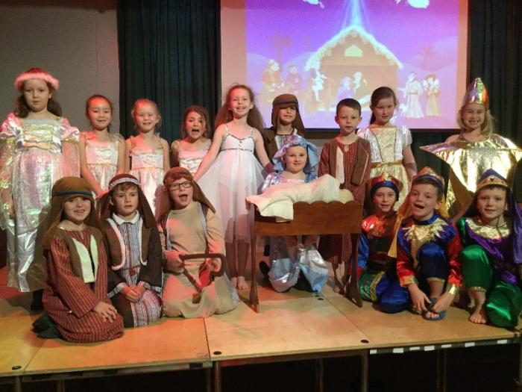

**Waterfront Hall Performance**

We were honoured to have had our choir invited by the Soldiers’ Charity to sing at the Waterfront Hall in June. This was part of the VE Day 70th Celebration. Our choir performed fantastically and thoroughly enjoyed this experience. The evening was greatly supported by the parents and families from Ballydown.

***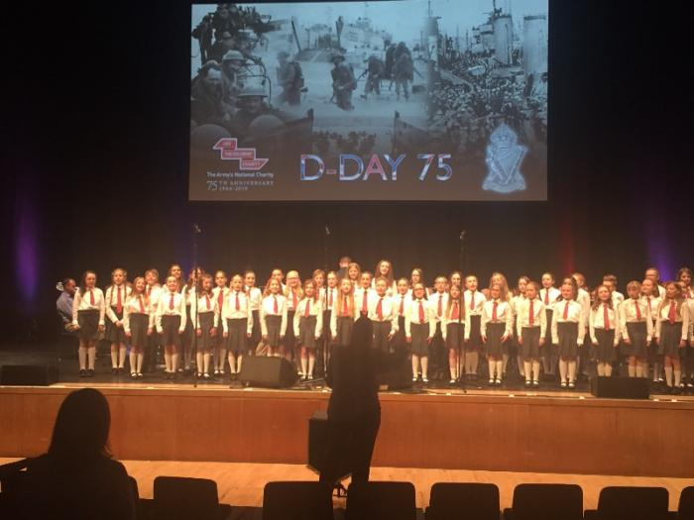***

***Key******Stage******2******Spring******Concert***

The annual spring concert in March once again show cased the musical and creative talents of our Key Stage 2 children. The pupils involved with violin, guitar and brass tuition entertained the very appreciative audience to a variety of pieces.

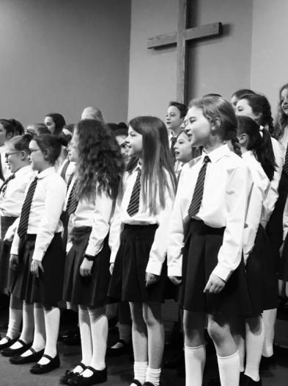

The Ulster Scots traditions were enthusiastically displayed through poetry, drumming and a fabulous spectacle of Highland dancing.

Once again, one of the highlights of this event was the liaison between P5 and those from the Banbridge Social Education Centre who used to meet in the former Ballydown School. They formed a Makaton choir which performed two pieces at the concert.

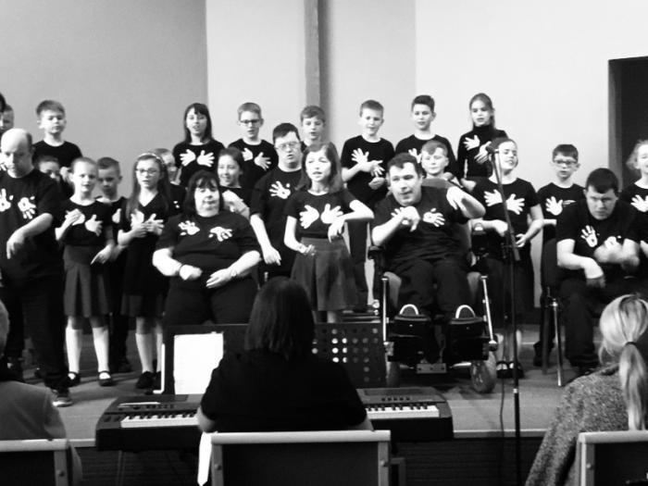

***Shared Education Year 2***

We continued to develop our partnership with St. Francis’, Aghaderg. Most classes participated in a variety of activities in both schools and enjoyed trips to various locations. The CASE Peace IV project also enabled us to fund shared training for staff; Numicon training for whole school numeracy development. Our nursery continued the 2nd year of their project, Learning from the Start, with St Patrick’s, Mayobridge. They enjoyed 6 shared sessions, including trips to the farm, Sticky Fingers and Slieve Gullion.

***P7******Musical***

In June 2019 the P7 children entertained us to a western themed musical, “Ye Ha.” All of the pupils thoroughly enjoyed playing their roles in front of enthusiastic and supportive audiences.

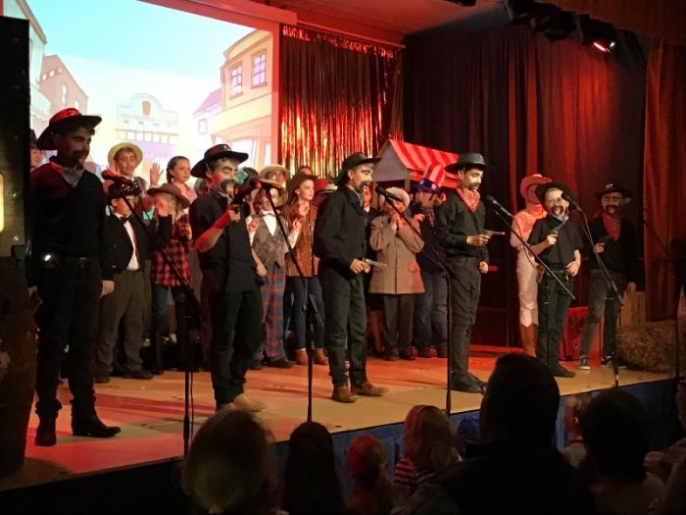

***Fiddle Tuition***

We were delighted to welcome back to Ballydown Mr Keith Little to tutor selected groups of P4, 5, 6 & 7 pupils in traditional fiddle playing.

**[](https://www.google.co.uk/imgres?imgurl=https://ubisafe.org/images/violin-transparent-cartoon-4.png&imgrefurl=https://ubisafe.org/explore/violin-transparent-cartoon/&docid=ym0GsicUuMpSAM&tbnid=az7R3afXiWOVVM:&vet=10ahUKEwjuwrjHvPndAhUICcAKHW88B7MQMwiLASgVMBU..i&w=256&h=256&itg=1&hl=en&safe=active&bih=789&biw=1536&q=fiddle%20cartoon&ved=0ahUKEwjuwrjHvPndAhUICcAKHW88B7MQMwiLASgVMBU&iact=mrc&uact=8)**Parents purchased fiddles and pupils attended weekly tuition sessions. The pupils’ progress was showcased in excellent performances during the Spring Concert.

This tuition service was funded by the Ulster Scots Schools Programme.

**Linen Lab**

[](https://www.google.co.uk/url?sa=i&rct=j&q=&esrc=s&source=images&cd=&cad=rja&uact=8&ved=&url=https://www.amazon.com/slp/inspirational-school-quotes/hkgy3whow4rx6xa&psig=AOvVaw3iuLKTp4_UJeOGaMWJ-2DC&ust=1569314219785196)P7 pupils were delighted to work with Rachel Fitzpatrick, a professional artist on the Linen Lab Project. This project entailed looking at all aspects of linen form flax to highly finished fine damask. The pupils made paper flax flowers for a major 3D art installation in the F.E McWilliams Gallery. They also planted flax seeds and created unique patterns on linen samples. Our thanks to Rachel who faithfully attended every Wednesday and Louise Rice the project coordinator.

***Nursery Music Workshop***

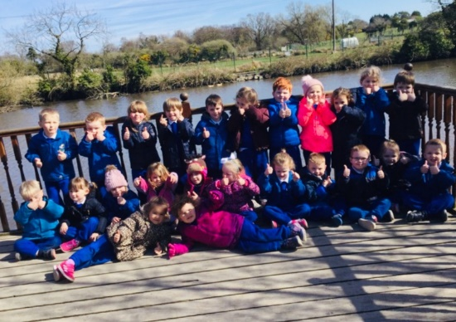

The nursery enjoyed a music workshop led by two of our parents Mr & Mrs Harper-Simmance.

***Art***

P5 - P7 attended the Art Club which met on Tuesday afternoons. They participated in individual and group projects using a range of media.

Children throughout the school continued to participate in a variety of local, national and regional art competitions including those organised by Tesco, U.T.U and local organisations.

Primary 2 children in Miss White’s class and P5 children in Miss Orr’s class worked collaboratively in a remote art project with Rathlin Island artist Ann Henderson organised by Kids’ Own Publishing. The cross curricular project which involved the use of creative and expressive areas of the curriculum and I.C.T. was on the theme of ‘Skin’.

**P.E** **& Sporting**

**Extra-Curricular** **Activities**

**Highland Dance**

****We were delighted this year to avail of the services of Miss Kathryn Stewart to teach highland dance to all our pupils from P2 – P7.

Dance is an integral part of the PE curriculum and this traditional form of Scottish dancing was greatly enjoyed by both pupils and teachers throughout the school.

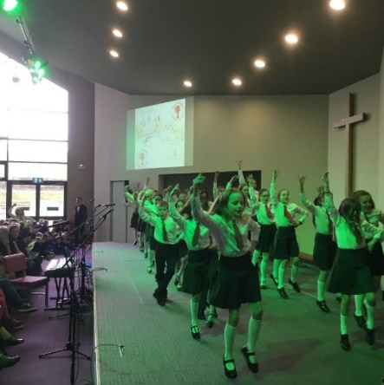

Kathryn’s teaching style instils both confidence and enthusiasm in the pupils and we look forward to being able to showcase their talents for years to come.

This tuition service was funded by the Ulster Scots Schools Programme.

***Netball***

**Netball continued to be an extremely popular after school activity in 2018-2019. Nearly fifty girls from P5-P7 came out to practise each Thursday afternoon. The girls enjoyed participating in a team sport, learning new skills, keeping fit and having fun!

In Term 2, the A team entered the ABC Primary Schools Netball League. Throughout the term they played a series of matches against 4 local schools. The team played really well and reached the prestigious cup section of the ABC Area Primary Schools Netball Finals for the third year running. These were held in Lisburn Racquets Club in May 2019. It was a great day of netball for Ballydown.

**In June 2019 the team took part in the Iveagh PS tournament. They reached the final but unfortunately lost out in a hard fought battle with Windsor Hill. The girls received runner-up medals and one pupil was named ‘player of the match’.

# **Rugby**

This year we had a cracking good rugby team who had the pleasure of participating in the annual rugby tournament at Kingspan stadium, the home of Ulster rugby. Qualification for this tournament involved playing in the West Down Tournament at Banbridge Rugby Club. We were delighted that this tournament was organised by Ruckus Rugby who are doing a tremendous job coaching rugby developmental skills throughout the school.

Our success in the West Down Tournament meant that we qualified for the top tier of primary schools at Kingspan. Our team played extremely well encountering the trinity of possible results.

Again we were delighted to be invited to the prestigious Campbell College Tournament. Unfortunately, we had to deal with a depleted squad and this was further reduced with injuries on the field of play. Consequently, we combined our squad with pupils from Campbell Prep. and completed the tournament enjoying the friendship that can naturally arise between players on a rugby pitch.

We are delighted that rugby continues to flourish at Ballydown and we encourage parents to support the opportunity for pupils to develop basic ball handling skills and techniques as coached by Ruckus Rugby.

***Football***

EVO’s Soccer School continues to provide coaching throughout the year for all interested pupils from P1 – P7. Our school football team participated in the regular tournaments organised at Cheney Park. The team was captained by Robbie Nicholl who played a starring role in leading the team and also as top goal scorer! Overall we had an enjoyable season and welcome the role played by Mr Cairns in assisting with the coaching of the team.

***Hockey – Girls***

Approximately 35 girls attended the weekly hockey sessions. The majority were from P4 and P5. All were very keen and enthusiastic. They took part in a number of different activities such as; skill based development techniques, skill based games (which focuses on specific skills) and mini games.

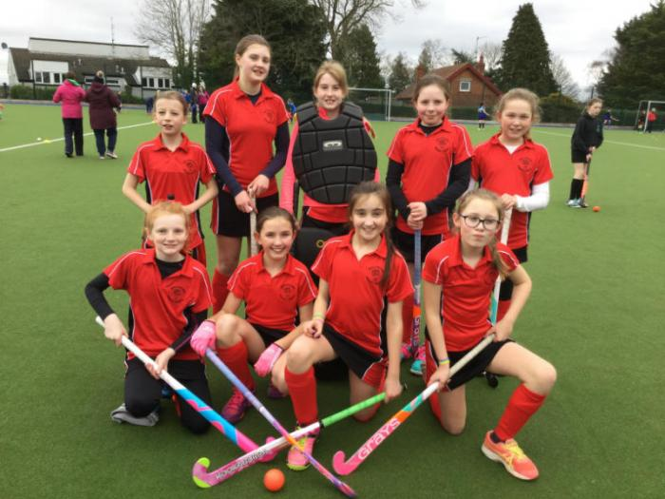

The P6 and P7 were taken by Mrs Duke and the P4 and P5 were taken by Mrs Wright.

***Hockey – Boys***

An enthusiastic group of boys came out to hockey practice on a Tuesday afternoon in the second and third terms. We are aiming to have the boys compete in some competitions this year.

**Community Sports’ Week**

In March our P4-P7 pupils took part in a week of activities organised by Dave Selwood from Youth Ministry. The children had a great week culminating in a parents’ evening. 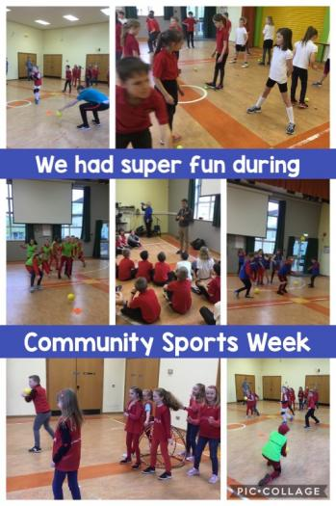

***Table Tennis***

P6 and P7 continued to be given the opportunity to play table tennis on Wednesday and Thursday mornings from 8.45 a.m. They are ably coached by Arnold Morgan – a local table tennis coach and enthusiast.

Some pupils have also been attending the Tuesday and Wednesday evening table tennis coaching sessions held in the school.

Our P6 & P7 teams played very competitively in tournaments held at St Mary’s Primary and the NI finals at Lisburn Racquets Club.

***Swimming***

P4 – P7 receive swimming lessons in Banbridge Pool. Each class attends for 6 weekly sessions.

# The P7 children undertook valuable Rookie Lifeguard Training where they were taught life saving techniques

***Athletics***

Athletics forms a major part of our P.E programme in Ballydown. Children took part in weekly Athletics lessons and unless the weather was very inclement the lessons usually took place on the polymeric pitch or grass pitch. In April we were delighted to welcome our new Athletics coach Mrs Helen McCarten. Helen works with each class on Fridays to teach and develop athletic skills.

***Cross Country***

We took part in the Flahavans Athletics NI Primary School Cross Country League – southern area. Girls and boys teams were entered in the three rounds of the league which were held in Lurgan Park, Armagh and Banbridge Academy. Our girls’ team and an individual boy qualified for the finals in Dundonald. We did very well against very tough competition, with the team finishing in the top 10. Our individual boy, Robert Russell finished in the top half of the boys.

**Mile-A-Day**

Teachers are encouraged to take their class outside each day to walk/run a mile. This has been a great idea for encouraging children to be more active and teachers have reported that it helps children to concentrate in class. Mr Murphy runs a competition to find out which class walks the most at the end of each month!

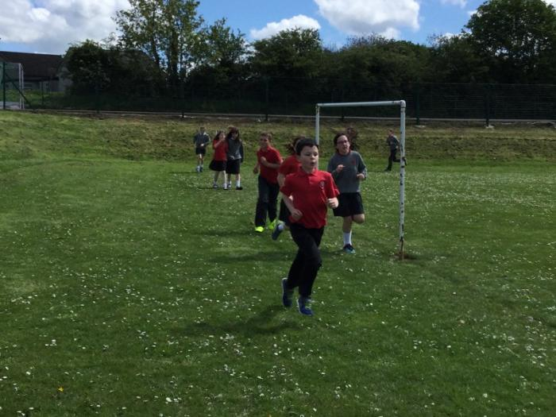

***Monday Mile***

We have a group of very enthusiastic runners who come every Monday morning to run before school. They are supervised by two of our dedicated parent helpers.

***Ballydown Fun Run***

In May, everyone in school took part in the fun run which began with an exciting warm-up session in the hall. Children, and most staff, ran, jogged or walked around our school grounds.  Ballydown P.T.A. and Tesco provided us with delicious fruit and juice to refresh us afterwards. Children were sponsored raising a fantastic £2150 for school funds. Many parents came to spectate or join the children in the run.

***Sports’ Day***

Sports’ day took place in June with all classes including the Nursery, running a flat race. P1 – P7 then had a novelty race each. After a break, KS 2 held a marathon race, relay races and long jump competitions.

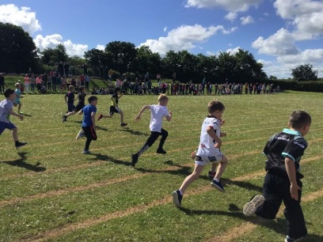

The **Nursery** also had a very successful sports event attended by many parents and grandparents. The children were divided into groups of 4-5 and completed a circuit of different activities. Refreshments were also served. Parents eagerly took up the challenge of taking part in some of the events, to the amusement of the children. Medals were presented by the Principal to the children at the end

**Santa Run**

In December, children and staff entered into our festive Santa Run dressed as elves, fairies or adorning Christmas jumpers and hats! It was a very colourful display. The event started with a warm up in the hall, accompanied by appropriate seasonal music.

***O’Connor School of Irish Dance***

Jigs, reels and team dances were enjoyed by many children in P1 – P3 and P4 – P7 when they attended the Irish Dancing classes on Mondays as an after-school activity. Their dance teacher, Clare O’Connor’s enthusiastic approach allowed children to develop their dance skills and build their confidence in a fun learning environment. Clare also held dance classes on Friday evenings.

1. **Child Centred Provision**

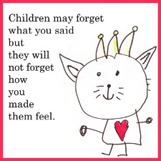

***Safeguarding and Child Protection***

Mrs Irvine acted as designated teacher during Mrs Baird’s absence. Mrs Lindsay was designated teacher alongside the principal. Mr Cassells was elected as the new Designated Governor.

During 2018-19

* The Safeguarding and Child Protection Policy has been updated
* Safeguarding and Child Protection Procedures have been reviewed and updated
* Child Protection Parents’ Guide has been updated and a copy was sent out to all parents
* Annual Child Protection training was carried out for Teaching, Non-teaching staff and parent helpers
* Designated Teacher photos and displays were updated in May.
* ETI safeguarding proforma has been evaluated by Safeguarding Team
* Children participated in a range of Child Protection related activities throughout the year e.g. Anti-bullying week, E-safety awareness, Circle-time and PDMU.
* There are no children on the Child Protection register.

***Special Needs***

Total number of children on the Primary SEN register June 2019 is **45** (**13%** of Primary School)

11 of these children have **Statements of SEN** and have been allocated classroom assistant hours.

Annual Reviews were completed for **9** children with Statements for SEN’s and **2** Transfer Reviews were completed for Primary 7 pupils with Statements of SEN’s.

**26** children have been receiving Small Group Literacy Support while **19** Children have been receiving in-class support.

***School Council***

A school council is a formal group of pupils within a school who are elected by their peers to represent them and their views. In line with the UNCRC, and the Executive, all government departments and public bodies have a duty to ensure that the views of children and young people are sought in matters which impact on their lives. As outlined in the policy for school improvement, 'Every School a Good School', DENI wishes to see a greater focus on engagement within schools, particularly with pupils.

In Ballydown, children from P4 – P7 elect peers from their class to sit on the School Council which is made up of 12 members. In 2018/19 the following were school council members:

***Committee****:-*  Robert Russell, Anna Wright, James Bowman, Eva McKay, Mollie Gibson, Andrew McQuiston, Ella Dodds, Rebekah Kettyles, Louise Chambers

Examples of discussions included improving the school grounds, Golden Time, play equipment, Red Day and School uniform sale. The council raised £300 towards school resources and play equipment.

***Eco- Club***

Members of the Eco- Club were once again elected by their peers following a presentation by those keen to get involved. The Club meets on Tuesday afternoons in Autumn and Spring. The focus this year was on ‘Pollination’. Ballydown continues to be a Polli:Nation school within Northern Ireland [(www.polli-nation.co.uk/](http://(www.polli-nation.co.uk/)). and continue to look closely at how to provide shelter and food sources for bees, butterflies, moths and caterpillars.

Our Eco-garden has once again produced an exciting crop of potatoes, onions, cabbages, peas, beans and rhubarb, along with a variety of herbs and flowers. The greenhouse was also used to propagate seeds as well as a space to grow strawberries and tomatoes. Eco-members have once again enjoyed eating their harvest as well as making fresh apple juice, carrot cupcakes and stewed rhubarb! Eco-members are continuing to put up and fill bird feeders around the outdoor classroom to attract a variety of garden birds. The Eco-club have also continued to look at how the school’s Rath area can be used and developed for outdoor learning and they enjoyed building a new bug hotel.

As always, special thanks go to our Caretaker, Jeff, and to Mr Glass for all their help throughout the year. We look forward to another successful year next year!

**Tea with the Principal**

Mr Murphy introduced his monthly ‘Tea with the Principal’ award. Each month he sets a target for the children to work towards. The class teacher choses a winner from each class to be selected to receive an award in Celebration Assembly and have a special treat with Mr Murphy for breaktime.

***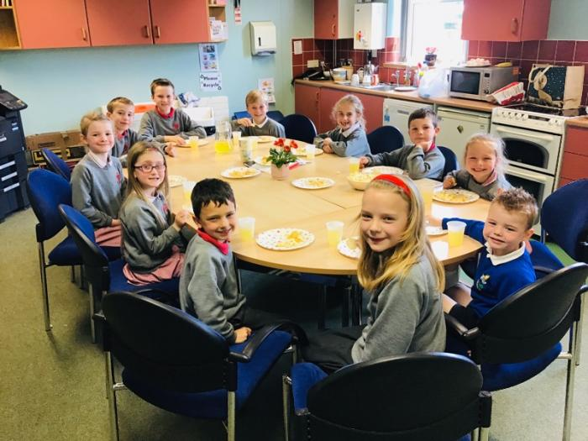***

***Buddy System***

Ballydown continued to operate our buddy system whereby P7 children, wearing hi viz vests, interacted with P1 – P4 children in the morning and at break time. They were being mindful of looking out for solitary children, ‘nice’ play with each other or those needing support and encouragement in play.

The benefits of a Buddy systems are –

* gives children the opportunity to practise the important values of respect, care, responsibility, friendship and including others.
* It helps children, who are given this role to feel valued.
* it teaches important social skills and
* creates a caring ethos in the school.

1. **Effective Leadership**



**New Principal**

In January we welcomed our new Principal Mr Brian Murphy to Ballydown. We are delighted to have him leading our school and wish him all the best for the future. We look forward to exciting times in Ballydown under new leadership.

***Strategic Leadership Team******2018/19***

Mr B Murphy *Principal*

Mr T Russell *Vice-Principal*

Mrs K Blair *Senior Teacher KS2*

Mrs J Wright *Head of Foundation/ KS1*

***Middle Management***

Subject co-ordinators are responsible for their area of the curriculum ensuring there is breadth and continuity in skills and content.

**Co-ordinators 2018 -2019**:-

Literacy Mrs Blair (KS2) Mrs Lindsay (KS1)

Numeracy Mr Murphy/ TBC

World Around Us Mr Russell (KS2) Mrs Russell (KS1)

Music Mrs Blair (KS2) Mrs Irvine (KS1)

Art Miss White

Nursery Mrs Hamilton

Head of Foundation/KS1 Mrs Wright

PDMU/Assessment Miss Orr

ICT Mrs Glass

SENCO Mrs Baird

One of our main areas for professional development in 2019/20 will be in relation to developing further the role of the co-ordinators. Staff Development Days and Curriculum Meetings will deal with this aspect during the year.

The school continued to use the ETI self-evaluation document - Effective Practice and Self –Evaluation Questions for Primary Schools.

***Continuing Professional Development***

During the 2018/19 year, curriculum and staff development were linked to DENI’s “Every School a Good School” policy. DENI provided schools with 5 Staff Development Days and 5 Baker Days to undertake curriculum and staff development. Once again, we focused on Data Analysis, analysing our standardised scores - setting targets at school, class and individual levels and tracking results from year to year. Transition Information – from class to class was completed. The staff also undertook Child Protection training. Training in the use of Numicon took place in January.

1. **School Connected to the Local Environment**

***Speech and Drama***

Over 50 pupils from P1 – P6 took part at the annual Banbridge Speech & Drama Festival in the Belmont Hotel. The festival was held during the first week of November and was attended by many of the local primary schools. We had outstanding results with a total of 17 medals- 4 gold, 8 silver and 5 bronze. 13 children were awarded certificates of merit. Four of our gold medal winners Seth Bell, Maisie Nicholl, James Bowman and Maire Harper-Simmance were invited back to compete for the “Champion of Champions”, resulting in James winning the overall shield for the Primary School section! The children worked extremely hard while preparing for the festival and as a school we are very proud of each child’s achievements. A huge thanks to the teachers for preparing the children for this event.

Children were offered an after school Speech and Drama Club taken by Sinead Lunney. Some children who attend, entered the Portadown Speech and Drama Festival.

***Shared Education***

Our CASE Cohort 1 funding continued in 2018-19. In this, year 2 of our partnership with St Francis PS, Aghaderg, Loughbrickland, 287 Ballydown children from P1, P2/3, P4, P5, P6 & P7 partnered with all classes from St Francis.

The purpose of shared education is to -

(a) deliver educational benefits to children;  
(b) promote the efficient and effective use of resources;  
(c) promote equality of opportunity;  
(d) promote good relations; and  
(e) promote respect for identity, diversity and community cohesion.

P1 pupils focused on play based and outdoor learning, physical development and enjoyed two joint visits to Scallywags in January and our teddy bears' picnic in Castlewellan in June. P1 teachers also completed 'Sharing through Play' teacher professional development in June 2019.

P2 & 3 developed their play, Personal Development & Mutual Understanding thinking skills & physical development. They also had a visit to Scallywags to get to know each other and a shared trip to Fort Evergreen in June.

P4s agreed to develop World Around Us with an emphasis on school in the past and investigative maths activities. They also had a shared assembly for parents and grandparents from both schools. Children also visited the F E McWilliam gallery, Tesco & Cultra. P4 teachers attended joint teacher professional development on collaboration through numeracy.

P5 pupils chose to concentrate on Numeracy & Technology with joint visits to W5 & Tesco.

P6 focused on Science, Technology, Engineering and Maths and Robotics with a shared visit to Whyte's Estate & the arboretum Castlewellan.

P7 continued their work on Science, Technology, Engineering & Maths and World Around Us projects and climbed Slieve Gullion together.

We had very positive evaluations from children, parents and staff about the impact of shared education and have secured funding for joint training for 2019-20. We look forward to all children in both schools being involved in 2019-20.

**Nursery Shared Education – “Sharing from the Start”**

Nursery children were involved with St Patrick’s in Mayobridge organising library visits, STEM activities (including a visit to our Rath) and engaging with Boogiebeats (Music and Movement) and Sticky Fingers Arts. They also had a joint visit to Slieve Gullion.

The children visited St Patrick’s - engaging in outdoor play and a further Boogiebeats session.

They had very enjoyable experiences and were joined by a number of nursery parent volunteers.

***Credit Union Quiz***

Our congratulations to our P7 ‘Credit Union Quiz Team’ who won the area heat, qualifying for the finals in Armagh City Hotel.

*Team: Rachel Greer, James Clark, Jamie Ramsey, John Shannon*

*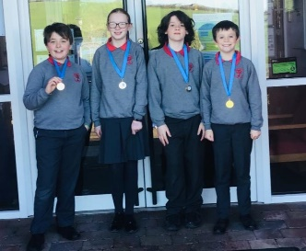*

***PTA***

The PTA continues to play a very

important role within the school and the

Board of Governors record their thanks for their commitment to raising funds (see appendix A).

The committee is made up of the following: -

*Chairperson* Lisa Dodds

*Secretary* Joe Robertson

*Treasure* Joanne Hobson

*Teacher Reps* T Russell

J White

*Committee Members* Gavin Hughes

Nicole Rouat

Mark Crothers

**Parent Helpers**

A huge thank you must go to our group of committed Parent Helpers who give of their time to count dinner money, attend trips, help class teachers with secretarial tasks etc. They are very much appreciated by the whole school community.

**Charities** **–** **2018/19**

The school supported the following local and national charities/organisations:

Cedar Foundation

(Christmas Stamps) £218.24

Poppy Appeal £254.58

Angling Trust (Dromore) £100

Hospice

(P4 Coffee Morning) £70.00

Fields of Life £408.00

SANDS £250.00

SE Project School for the Deaf £400.00

**Parent** **-** **Teacher** **Consultations** **and** **Information** **Evenings**

We see the value in consulting with parents as ultimately they benefit the education of our pupils. The following is a summary of the parent/teacher meetings and consultations during 2018/19:

Nursery Intake Meeting - June

Visitation Day - August

P1 Intake Meetings - June/September

P2-7 Introductory Meetings in September to discuss classroom procedures expectations and the year ahead

Nursery and P1-P7 - October Consultations and February Consultations

P6 Information/Curriculum Evening - March

P7 London Information Evening - March

Special Needs Annual Reviews - Feb/March

**Information** **sheets** were regularly dispatched from the office keeping parents abreast of activities. Information Sheets can be accessed on the school website. These will continue on a monthly basis.

The Nursery issue two information sheets and a song/rhyme sheet each month. One provides details of topics covered that month and how parents can enhance their child’s learning at home. A second newsletter gives information about routines, events, dates and general housekeeping in Nursery.

**A successful** **Open** **Day** was held in December 2018 for prospective P1 and Nursery parents. Parents also attended other school events such as our Christmas and Spring Concerts and sports day.

***Links with Post Primary Schools***

Ballydown joined several other feeder primary schools to ***Dromore High School*** in establishing closer links. This included a rugby coach who took 6 weekly sessions with all our P6 children culminating in a rugby tournament at Dromore Rugby Club in May 2018.

P5 children took part in a Science and Technology day. They participated in two stations – one involving Biology and the use of microscopes to identify pond creatures, - the second doing chemical investigations.

***Banbridge Academy***

Ms Cheng, a Chinese Language Assistant, on placement with Banbridge Academy taught P4 – P5 classes some Chinese each week.

***Banbridge High***

In December 2018, P7 children spent a Transition Day in Banbridge High School, where they experienced a range of subjects and became familiar with the school through the movement to and from rooms at the end of periods. They also had the opportunity to meet children from a range of feeder primary schools.

**Outside Agency Afterschool Activities**

Evo Soccer School

Ruckus Rugby

Galaxy Sport Coaching

Sinead Luney Speech & Drama

Irish Dancing

**Annual Attendance Rate**

2015/16 97.0%

**2016/17 97.6%**

**2017/18 96.7%**

**2018/19 96.9%**

**School Enrolment Numbers**

Sept 1998 248

Sept 2001 269

Sept 2003 284

Sept 2004 293 Plus 26 Nursery

Sept 2006 300 Plus 26 Nursery

Sept 2007 304 Plus 26 Nursery

Sept 2008 307 Plus 26 Nursery

Sept 2009 308 Plus 28 Nursery

Sept 2010 304 Plus 26 Nursery

Sept 2012 307 Plus 26 Nursery

Sept 2013 308 Plus 27 Nursery

Sept 2014 312 Plus 26 Nursery

Sept 2015 313 Plus 26 Nursery

Sept 2016 317 Plus 26 Nursery

Sept 2017 317 Plus 26 Nursery

Sept 2018 317 Plus 26 Nursery

Enrolment numbers show a continuing upward trend and that we are nearing our maximum enrolment capacity of 319 (plus children with formal statements of needs).

**Class** **sizes** **–** **September** **2018**

**Class Number**

Nursery 26

*These figures include children who have statements of educational need where there is additional classroom support provided by classroom assistants.*

P1 23

P1 24

P2 27

P2/3 30

P3 31

P4 30

P4/5 31

P5 32

P6 31

P6/7 30

P7 32

***Post******Primary******Transfers***

The table below shows the schools to which our 48 Primary 7 pupils transferred in 2019 and previous years are included to enable you to see the trends:

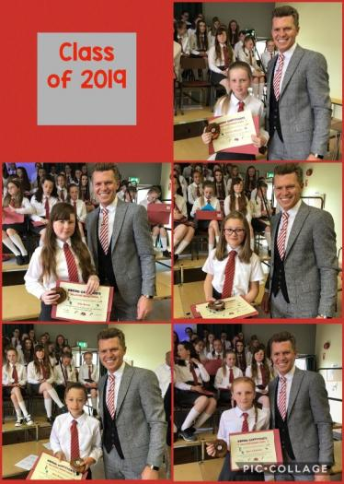

|  |  |  |  |
| --- | --- | --- | --- |
| **SCHOOL** | **2017** | **2018** | **2019** |
| Banbridge Academy | 20 | 19 | 19 |
| Hunter House | 0 | 2 | 1 |
| Victoria College | 0 | 1 | 1 |
| Banbridge High | 5 | 10 | 10 |
| Dromore High | 7 | 7 | 9 |
| New Bridge Integrated | 9 | 1 | 3 |
| Rathfriland High | 1 | 0 | 1 |
| Lurgan Junior High | 1 | 1 | 0 |
| R.B.A.I. | 0 | 0 | 1 |
| Royal School Armagh | 1 | 1 | 0 |
| St Patrick’s College | 0 | 2 | 1 |
| Killicomaine Junior High  Hig | 0 | 1 | 0 |
| Newry High | 0 | 1 | 0 |
| Friends’ Lisburn | 0 | 0 | 1 |

We wish our P7 leavers every success in their new schools and look forward to hearing of their achievements in the future.

**Finance**

***No. 1 Account***

A current account is held with the Danske Bank. At 28th June 2019 the account had a credit balance of £4388.47

Notable Income included £350 from Irish Dance Tutor, £2,000 from PTA for consumable items in each class, Opus commission £333.38, Book Fair Commission £316.68 and the Giving Machine £16.41 & £700 for maths resources from PTA.

***No 2 Account***

The balance at end of June was £8,738. P6 children, in May 2018, began paying deposits for the 2019 London Trip and began a weekly savings scheme to cover the cost of the trip. The school received a grant from House of Commons of £1600 which was used to cover the cost of transport to and from the Airport, additional adult supervision on the trip and it helped subsidize the P7 day trip to Scotland.

The Nursery maintain a separate account which, at the 27 June 2019 was £952.27. The main source of income was from Nursery Fund Money. This pays for trips, equipment, ingredients for use throughout the year.

**Mullafernaghan** **School** **Trust**

The school continues to benefit from a Trust Fund instigated following the closure of Mullafernaghan Primary School. Tullymacarette received funds from this source up until it closed. As many of its pupils transferred here, so too did part of the proceeds of the fund. In 2018/19 the Trust gave the school £500 which purchased Activity Based learning resources for Year 4.

**School LMS Account**

As you can see from our school 3-year financial plan (see appendix B) our school budget is under pressure. Despite the fact that we have reached our maximum enrolment number and with careful financial management our income does not cover expenditure. The current formula for school budgets has not been amended since 2010 and does not take into consideration increasing costs.

**Conclusion**

Thank you for taking the time to read the Governors’ Report for 2018/19. As you can see Ballydown is a very busy place which offers so many opportunities to our children. We very much value your ongoing support to our school in helping to make it the place it is.

**Appendix A**

**PTA Account**

Our hard working and committed PTA work hard to organise fundraising activities throughout the year. They raise a lot of money which school uses to purchase items which we could not afford. Their hard work is very much appreciated, along with the support our school community gives in supporting these events.

|  |  |  |  |  |
| --- | --- | --- | --- | --- |
| **Date** | **Expenditure** | |  | **Cost** |
| Nov-17 | Teaching Sundries ( EACH CLASS GIVEN AN ALLOWANCE TO PURCHASE CONSUMABLE CLASSROOM REQUISITIONS) | |  | £2,000 |
| Feb-18 | Playground landscaping | | | £175 |
| Mar-18 | NI Climbing Frames (nursery climbing frame) | |  | £456 |
| Apr-18 | Storage Unit | |  | £1,500 |
| Jul-18 | Table tennis coaching | | | £720 |
| Aug-18 | Netball uniform | |  | £450 |
| Oct-18 | Teaching Sundries (EACH CLASS GIVEN AN ALLOWANCE TO PURCHASE CONSUMABLE CLASSROOM REQUISITIONS) | |  | £1,900 |
| Nov-18 | Gate padlocks | |  | £71 |
| Nov-18 | Text Service | |  | £348 |
| Dec-18 | NI Climbing Frames (buddy huts in playgrounds) | |  | £2,430 |
| Dec-18 | Microphone (assembly hall) | |  | £200 |
| Feb-19 | Ipads |  |  | £1,712 |
| Mar-19 | Speakers (assembly hall) |  |  | £685 |
|  |  |  | **Total** | **£12,647** |
|  |  |  |  |  |
|  |  |  |  |  |

|  |  |  |  |  |
| --- | --- | --- | --- | --- |
| **Date** | **Fundraising** | |  | **Income** |
| Oct-17 | Bend the Rules Day | |  | £922 |
| Nov-17 | Film night | |  | £865 |
| Mar-18 | Spring Concert | |  | £752 |
| Mar-18 | St Patricks Day Disco | | | £620 |
| May-18 | Fun Run |  |  | £2,806 |
| Jun-18 | Ballydown does Balmoral | | | £1,853 |
| Jun-18 | P7 Play - raffle, tuckshop, ice-cream | | | £855 |
| Oct-18 | Bend the Rules Day | |  | £1,180 |
| Nov-18 | Film night | |  | £752 |
| Dec-18 | P4 Play raffle | |  | £400 |
| Mar-19 | Nursery raffle | |  | £114 |
| Mar-19 | Spring concert | |  | £668 |
| Mar-19 | St Patricks Day Disco | | | £479 |
| May-19 | Fun Run |  |  | £2,150 |
| Jun-19 | Tea towels profit | |  | £329 |
|  |  |  | **Total** | **£14,705** |

Appendix B

**School Budget and Finance**

LMS Delegated Budget (DE Funding)

The delegated expenditure for the financial year April 2018-Mar 2019 is summarised below.

|  |  |
| --- | --- |
| **Income 2018/19** | **Expenditure 2018/19** |
| Total delegated budget:  £87,7258 | Total Expenditure:  £92,2981 |
| **Final Surplus/ Deficit**: -£45723 | |

Based on the current public sector financial climate we are facing yearly deficits. News form the Department of Education would indicate that the financial position for education will worsen further before it improves.

The current Common Funding Formula penalizes heavily schools such as ours with a low percentage of free school meals.

Despite very careful management of spending in our school we will continue to run into deficit. A recent meeting with the finance team at the EA confirmed that the school are doing all that they can to manage their budget, but the shortcomings in the Funding Formula will continue to have significant impact.